Infosys Springboard Virtual Internship
“Project Name: Automated Python Docstring Generator”
Milestone -1: - Automated Python Docstring Generator & Coverage Report

1. Introduction
This document describes Milestone 1 of the project Automated Python Docstring Generator & Validator. The goal of this milestone is to parse Python source code using the Abstract Syntax Tree (AST), extract structural information, generate baseline docstrings, and produce a docstring coverage report.
Milestone 1 focuses on analysis and groundwork, not on stylistic perfection. The generated docstrings act as a starting point for developers.

2. Objectives of Milestone 1
- Parse Python source code using AST
- Identify:
  - Classes
  - Functions
  - Methods
- Extract:
  - Function / method names
  - Parameters (excluding self)
  - Local variables
  - Return values (basic inference)
  - Existing docstring presence
- Generate baseline docstrings automatically
- Produce a docstring coverage report
- Provide a Streamlit UI to visualize results

3. System Components (Milestone 1 Scope)
3.1 Backend (AST Parser & Analyzer)
- File: parser.py
- Responsibility:
  - AST traversal
  - Metadata extraction
  - Docstring generation
  - Coverage analysis
3.2 Frontend (Streamlit UI)
- File: app.py
- Responsibility:
  - File upload
  - Display generated docstrings
  - Show coverage metrics and reports

4. Code Walkthrough – parser.py
4.1 CodeAnalyzer Class
class CodeAnalyzer(ast.NodeVisitor):
This class extends ast.NodeVisitor to traverse the AST tree.
Attributes
- self.classes → Stores extracted class metadata
- self.functions → Stores extracted standalone function metadata

4.2 visit_ClassDef()
def visit_ClassDef(self, node):
Triggered whenever a class definition is encountered.
Responsibilities
- Capture:
  - Class name
  - Class-level variables
  - Methods inside the class
  - Whether a docstring exists
Output Structure
{
"name": "ClassName",
"methods": [...],
"class_variables": [...],
"has_docstring": True/False
}

4.3 visit_FunctionDef()
def visit_FunctionDef(self, node):
Triggered for standalone functions.
- Extracts function metadata using _extract_function()
- Appends it to self.functions

4.4 _extract_function()
def _extract_function(self, node):
Core helper method for function/method analysis.
Extracted Details
- Function name
- Parameters (excluding self)
- Local variables (from assignment statements)
- Return value (basic detection)
- Existing docstring presence
Sample Output
{
"name": "function_name",
"params": ["a", "b"],
"returns": "result",
"variables": ["x", "y"],
"has_docstring": False
}

4.5 generate_baseline_docstring()
def generate_baseline_docstring(item, is_class=False):
Generates a baseline docstring template.
Features
- Works for:
  - Classes
  - Functions
  - Methods
- Includes:
  - Title (Class / Function / Method)
  - Parameters section
  - Returns section
  - Local variables section (if any)
Purpose
Acts as an auto-generated starting point, not final documentation.

4.6 analyze_code()
def analyze_code(source: str):
- Parses Python source using ast.parse()
- Runs the CodeAnalyzer
- Returns structured metadata for further processing

4.7 generate_cover_report()
def generate_cover_report(analysis):
Produces a docstring coverage report.
Metrics Included
- Total classes
- Total functions
- Classes with / without docstrings
- Functions with / without docstrings
- Methods with / without docstrings

5. Code Walkthrough – app.py (Streamlit UI)
5.1 Page Configuration
st.set_page_config(page_title="Automated Docstring Generator", layout="wide")
Sets UI layout and title.

5.2 File Upload
uploaded_file = st.file_uploader("Upload a Python (.py) file")
Allows users to upload a Python file for analysis.

5.3 Code Analysis Flow
analysis = analyze_code(source_code)
report = generate_cover_report(analysis)
- Parses uploaded file
- Generates metadata and coverage report

5.4 Baseline Docstring Display
- Displays generated docstrings for:
  - Classes
  - Methods
  - Standalone functions
st.code(generate_baseline_docstring(...))

5.5 Coverage Metrics Display
Uses Streamlit metrics and columns to show:
- Total classes
- Total functions
- Docstring presence (with / without)

Validation Using PEP 257 & pydocstyle
As part of Milestone 1 enhancement, PEP 257 validation has been fully implemented using the pydocstyle library. This ensures that both existing and generated docstrings comply with standard Python documentation conventions.
8.1 Why PEP 257 Validation?
- PEP 257 defines official Python docstring conventions
- Enforces consistency across large codebases
- Detects missing or poorly formatted docstrings early
- Essential for CI/CD and professional-grade tooling

8.2 Validation Logic (Backend – parser.py)
A dedicated function validate_with_pydocstyle() has been added.
Workflow:
- Accepts a Python file path as input
- Runs pydocstyle.check() on the file
- Collects all violations with:
  - Rule code (e.g., D100, D102)
  - Error message
  - Line number
  - Affected object (class / function)
- Returns a structured validation report
Returned Structure:
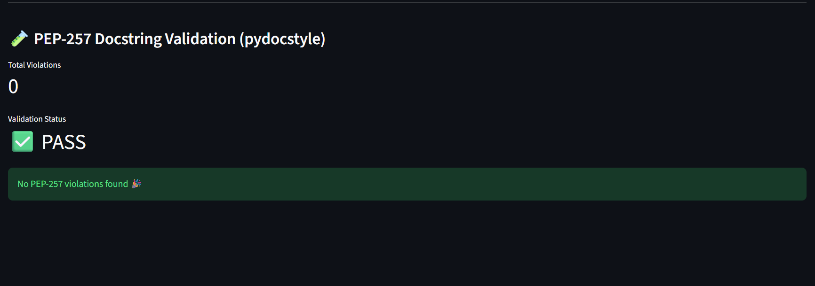

8.3 UI Integration (Streamlit – app.py)
The Streamlit interface now includes a PEP 257 Validation Section:
- Displays total number of violations
- Shows overall validation status (PASS / FAIL)
- Lists all violations with rule codes and descriptions
- Provides immediate visual feedback to the user
This makes the tool interactive and reviewer-friendly, allowing developers to inspect documentation quality instantly.

6. UI Screenshots (Placeholders)
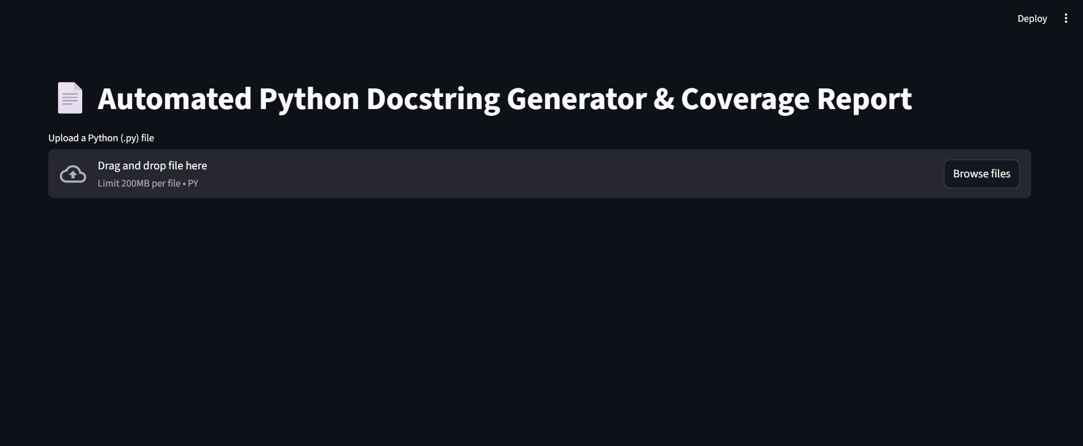
6.1 File Upload Interface
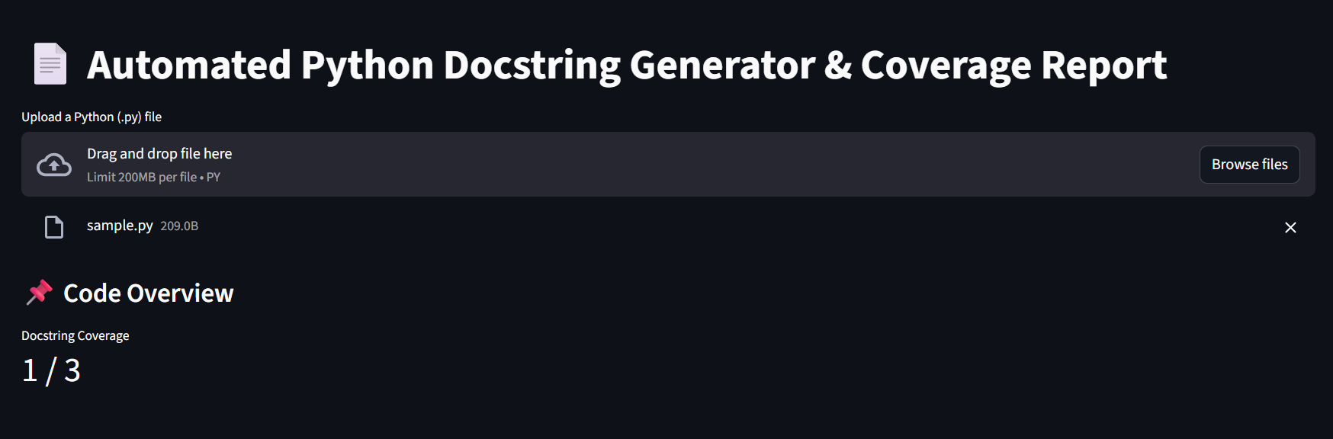

6.2 Generated Baseline Docstrings View
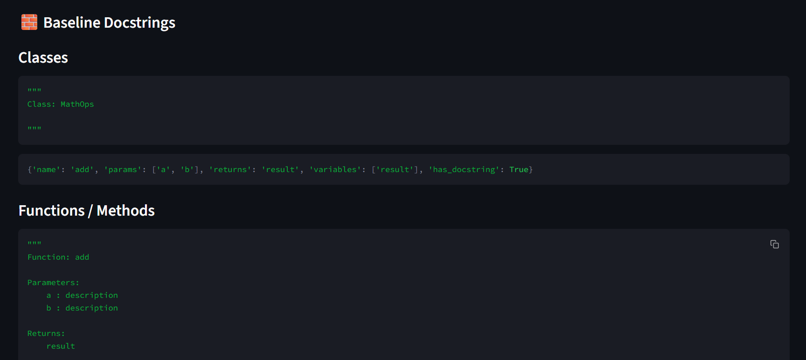

6.3 Docstring Coverage Report
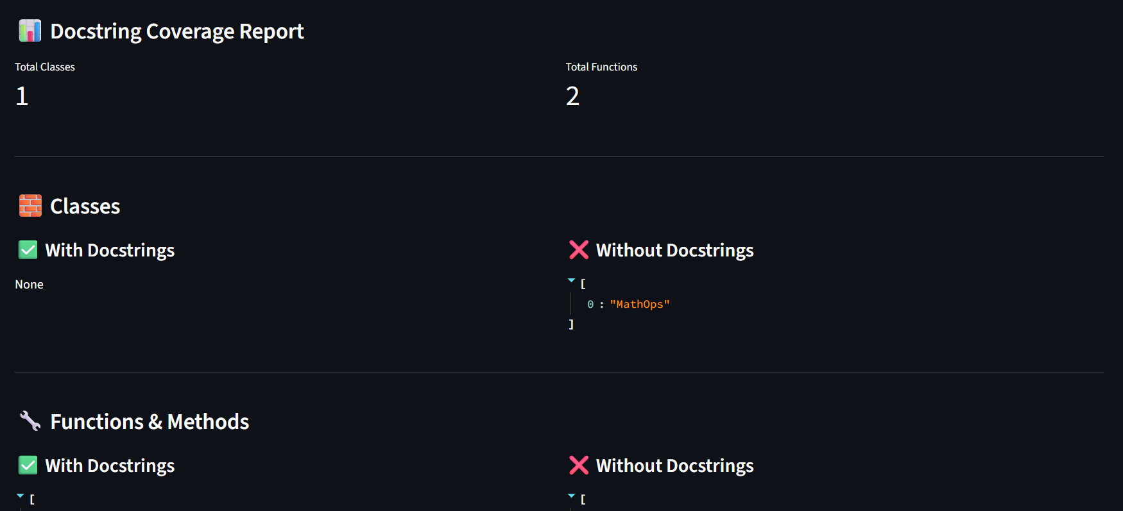

7. Output of Milestone 1
- Successfully parses Python code using AST
- Identifies classes, functions, and methods
- Generates baseline docstrings automatically
- Produces a structured coverage report
- Visualizes results via Streamlit UI

8. Limitations (Milestone 1)
- No advanced type inference
- Return value detection is basic
- Docstrings are templates, not semantic descriptions
- No CLI or CI/CD integration yet

